WEB322 Assignment 1 Report

Brendan Polius Prosper

UberGains

Table of contents

1. Home page

2. Meals Page

3. Login Page

4. Sign up page

Home Page

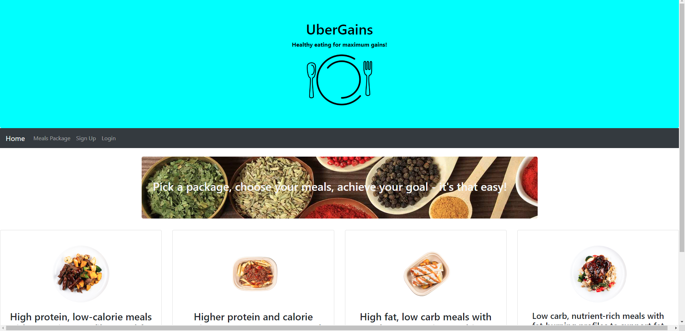

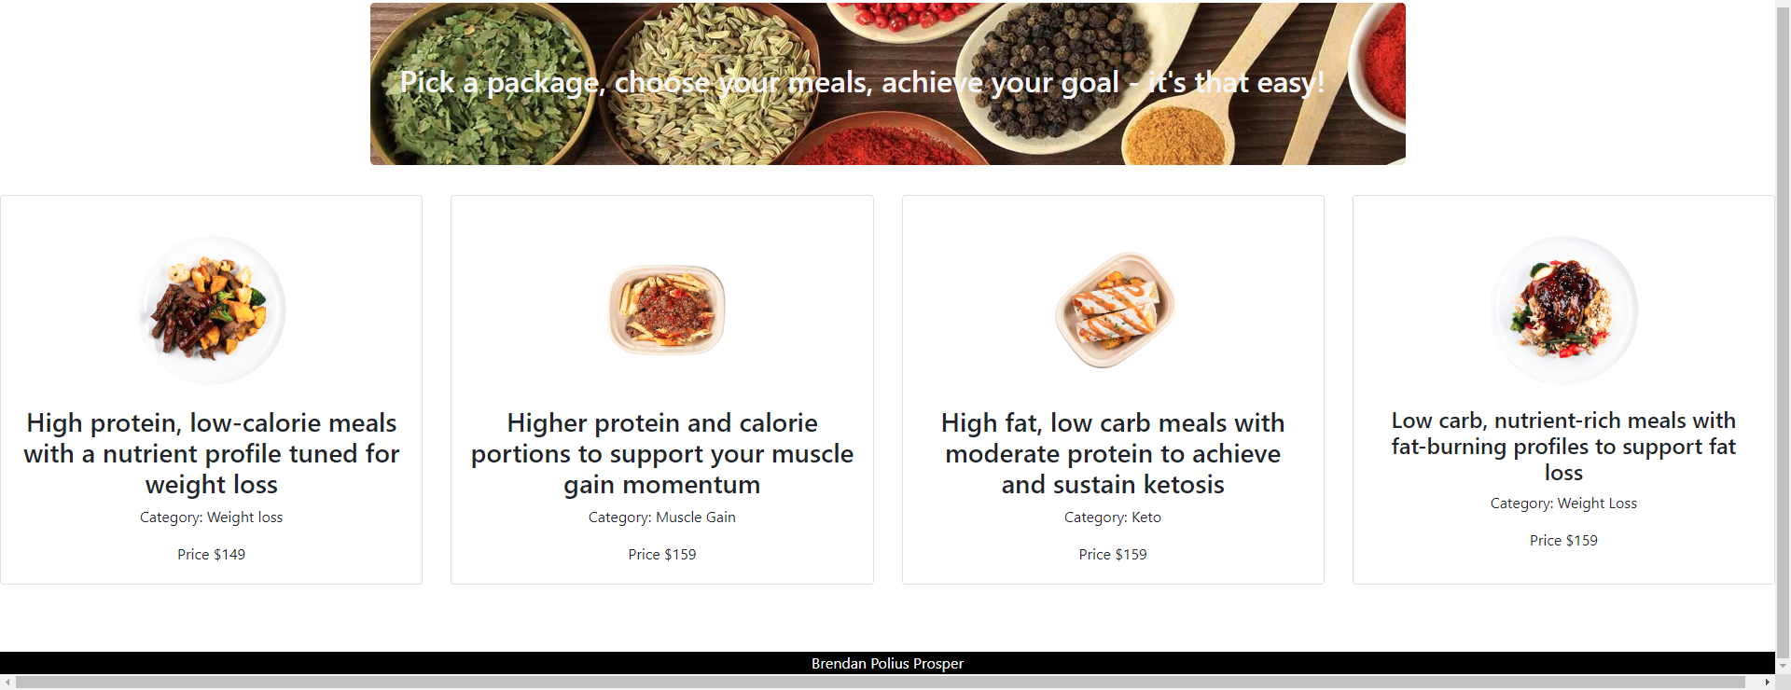

The homepage for my website has a proper header complete with text, a background, and a logo. The page also consists of a working navigation bar at the top that links all of my pages together. The content of the webpage contains a hero section with my slogan and the top packages section with the top packages. All of the content on the home page is functional.

Meals page

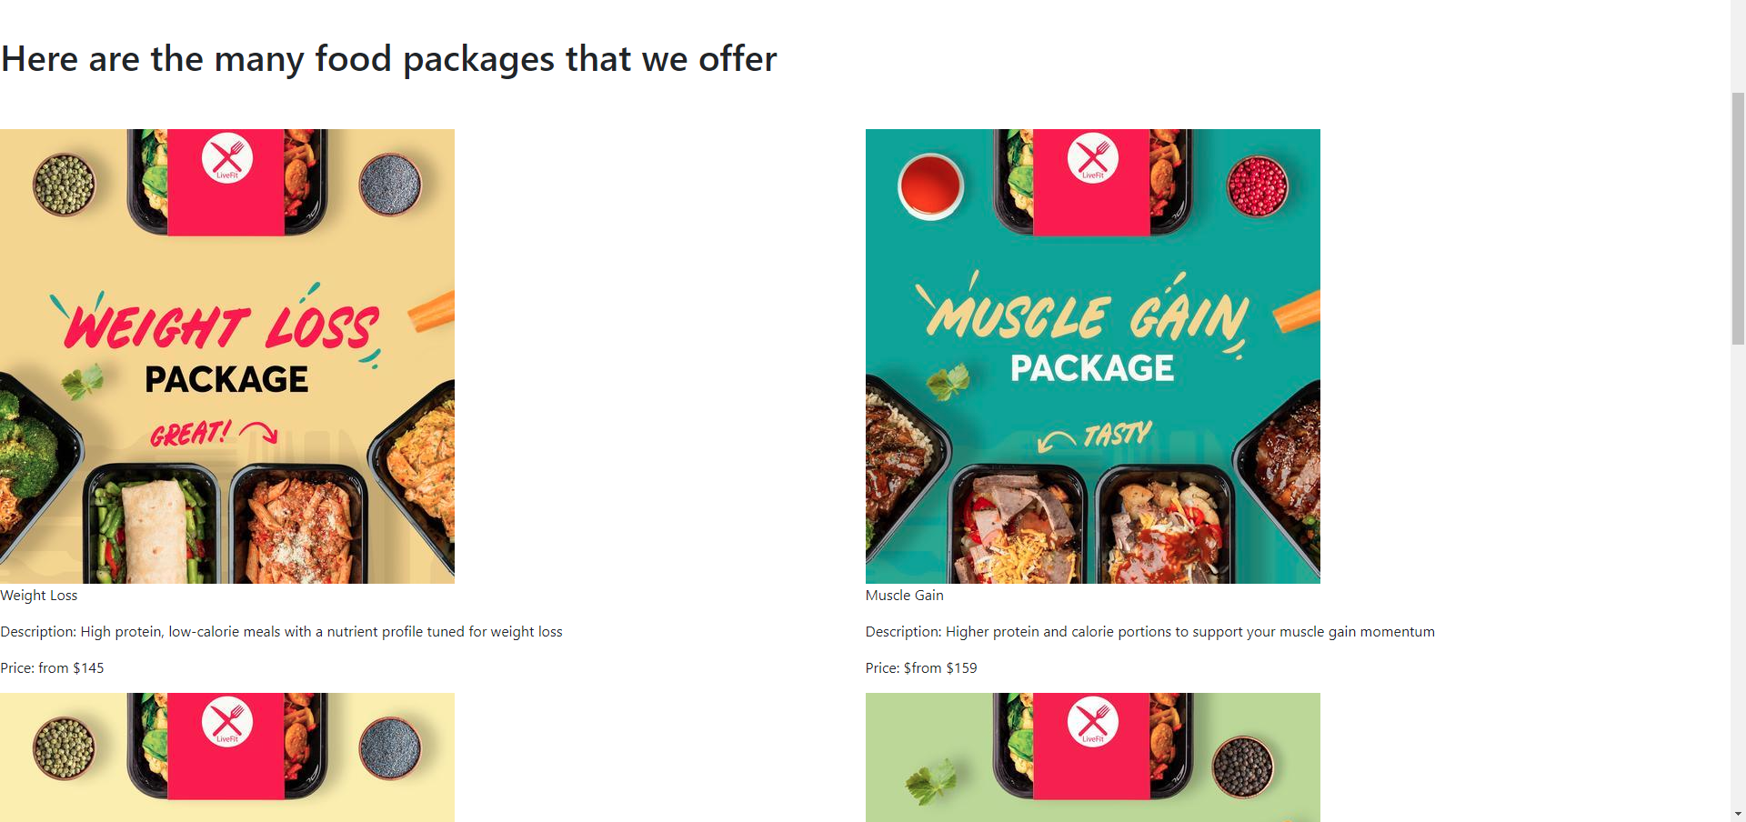

The meals page was done using a database that I created to create the name, description, image, and price for the web page. Then I used Javascript to loop through the entire database to display the content on the screen. The page functionality was met. The picture above is an example of the full page.

Sign in page

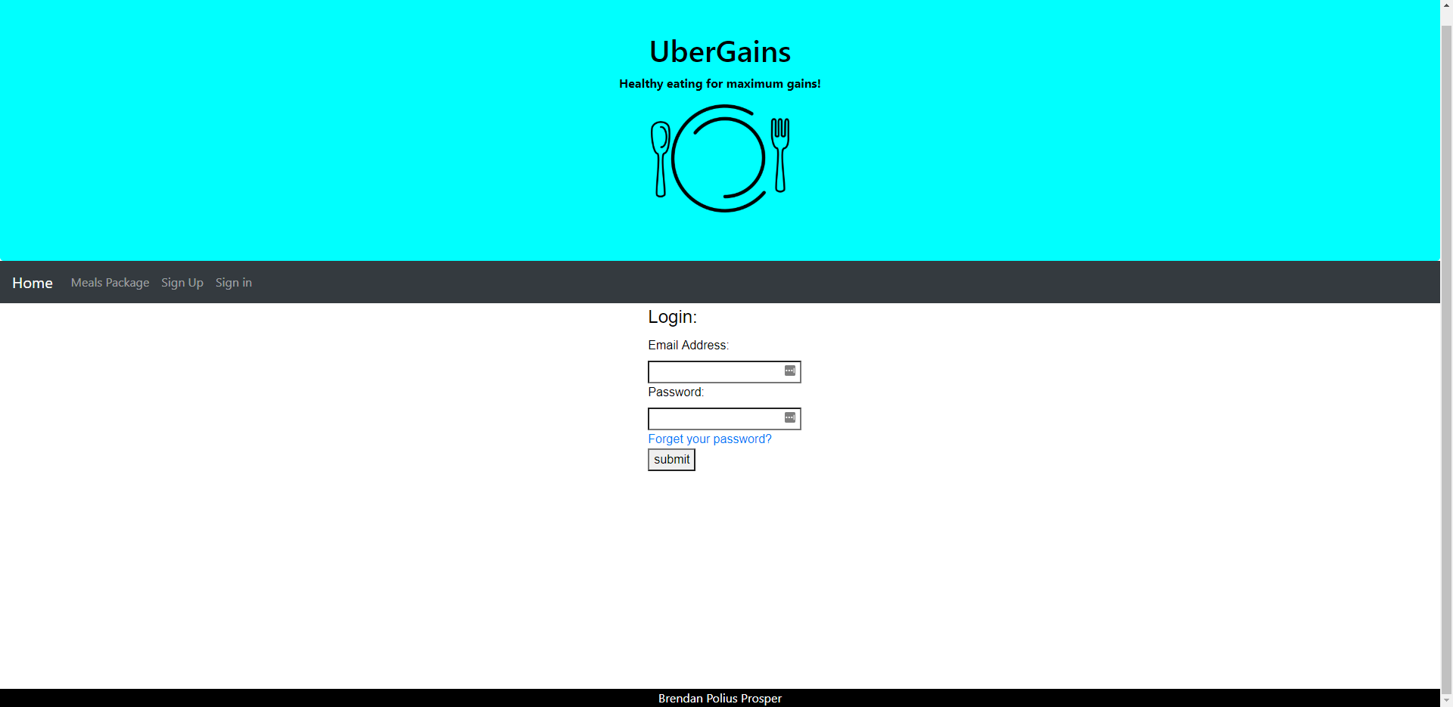

The Login Page consists of a simple login form that simply requests your email address and password. All input forms are required. The functionality was met for this page.

Sign up page

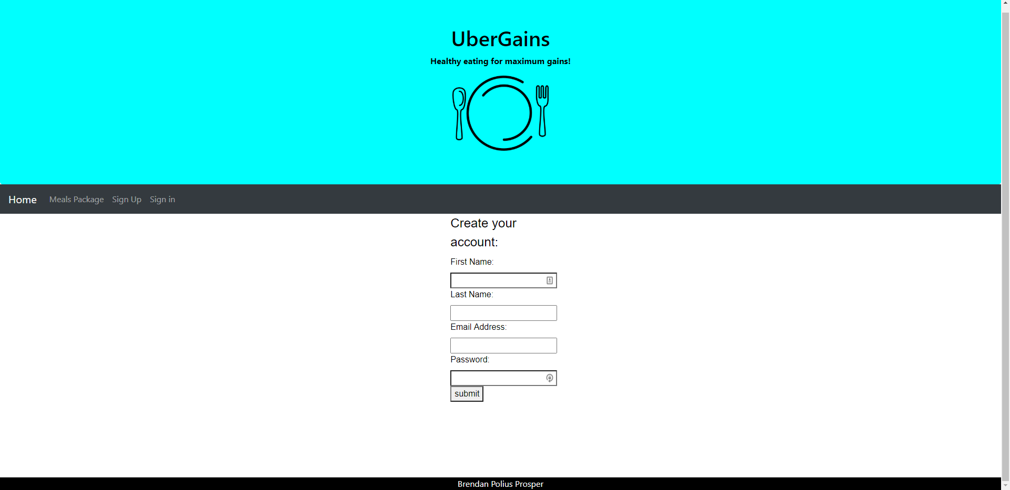

The Sign up Page consists of a simple login form that simply requests your first name, last name, email address and password. All input forms are required. The functionality was met for this page.